**Instar emergence (mp3 and hidden poem)**

## 2014

<http://piratepad.net/hwffrkCznO>

Guys if you reverse the clip and then add the unreversed clip onto the same track and play it simutaniously it spells out 242 232 3301242 232 3301242 232 3301242 232 3301242 232 3301242 232 3301242 232 3301242 232 3301242 232 3301242 232 3301242 232 3301242 232 3301242 232 3301242 232 3301 I think those are cooridnates idk tho.

So, if you take the 761.mp3 file from the 2013 ISO, use the visual equalizer of an audio tool (i used audacity), and you equalize the audio 3 times with all freqs down to -20dbm exept for 16 + 20 Khz you get text at > 15Khz in the spectogram.

seriously?

 nodody found that until now

 tinypic.com/view.php?pic[=29232f7&s](https://web.archive.org/web/20141202053558mp_/http:/piratepad.net/ep/search?query=29232f7&s)[=5](https://web.archive.org/web/20141202053558mp_/http:/piratepad.net/ep/search?query=5)[#.UtfDyZCxXVN](https://web.archive.org/web/20141202053558mp_/http:/piratepad.net/ep/search?query=.UtfDyZCxXVN)

is there another image hosting service that does not

[http://prntscr.com/2jsex1](https://web.archive.org/web/20141202053558mp_/http:/prntscr.com/2jsex1)      same link

anyway i would not call this text

[http://tinypic.com/view.php?pic=#315z78n&s=6](https://web.archive.org/web/20141202053558mp_/http:/tinypic.com/view.php?pic=#315z78n&s=6)    this is example how text looks in spectrogram, non related to 3301

yes, i read about aphex twin doing it years ago. but this is not an artifact, is it?

i have no audio processing experience, but this cant be random

also, i believe there is fm audio in that range

"shed your own circumferences" is most likely related to getting rid of human audio spectrum, i think

divinity within could be radio waves, and emerge is what you do to either listen to the radio waves or zoom in on those glyphs

maybe a bit far fetched, but i am pretty sure the glyphs are ment to be decoded

soo, back to irc, this is uncomfortable ;)

i first thought the lenght setting of the equalizer was meant to be set to the sum of the words, so the equalization was done with the three numbers at first, but it seems to work with just any nu

I think you should advertise this in the IRC.  Approaching people one at a time will take too long.  There will be someone with the knowledge of

 programs there that will be able to quickly assimilate your idea.#

At around 1:16, 76 seconds, there is a layer of music that resembles reversed playback, but im not sure. Also, Looking at a spectrograph, at 30 seconds, a letter seems to appear in the visualisation, a B, if im not mistaken Can i get some feedback? - KF

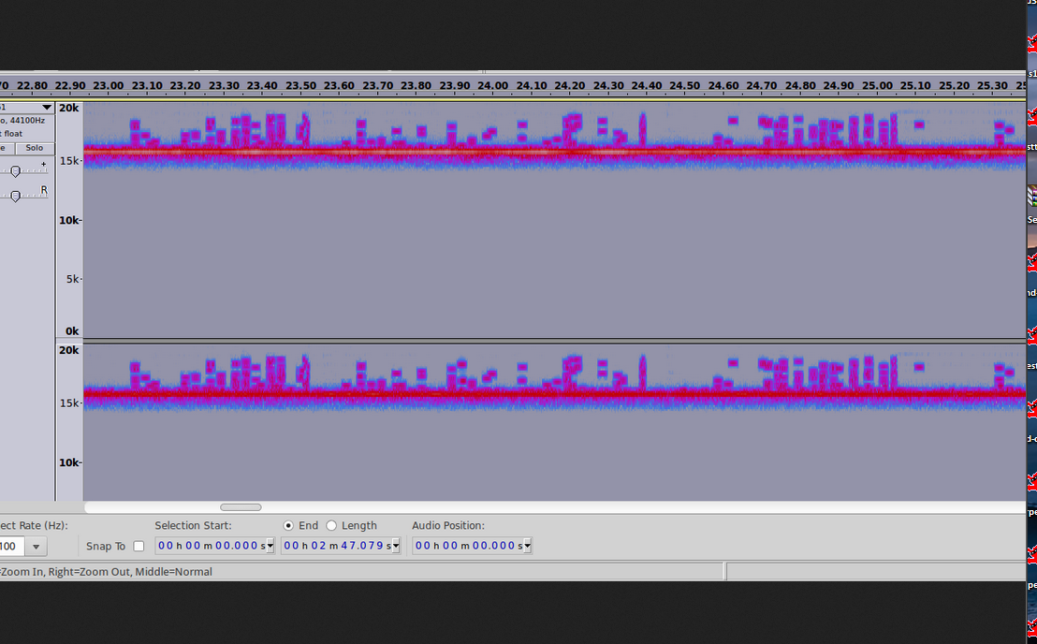

## 2013

Link to file (only mp3, look for whole disk image in: [dropbox link](https://www.dropbox.com/s/r7sgebdtmzj14s/3301)):

* <https://github.com/rtkd/iddqd/tree/master/2013/02>
* <https://infotomb.com/axn7i>
* backup: <https://anonfiles.com/file/b4a0a572aa4e307facb9e75e37a364b5>

Hiddnen poem:  
<http://prntscr.com/olxem>  
<http://prntscr.com/olxmr>  
<https://pastee.org/ujpxy>   hidden poem in ID tag of mp3 file

Parable 1,595,277,641

Like the instar, tunneling to the surface\n

We must shed our own circumferences;\n

Find the divinity within and emerge.

Cicada 3301 Song: The Instar Emergence (761)  
<http://www.youtube.com/watch?v=YA1fONCH-CY>

[](https://uncovering-cicada.fandom.com/wiki/File:Cicada_3301_Song_The_Instar_Emergence_(761)-0)

Spectograpms of mp3  
<http://www.anony.ws/i/2013/01/09/y7Avz.png>

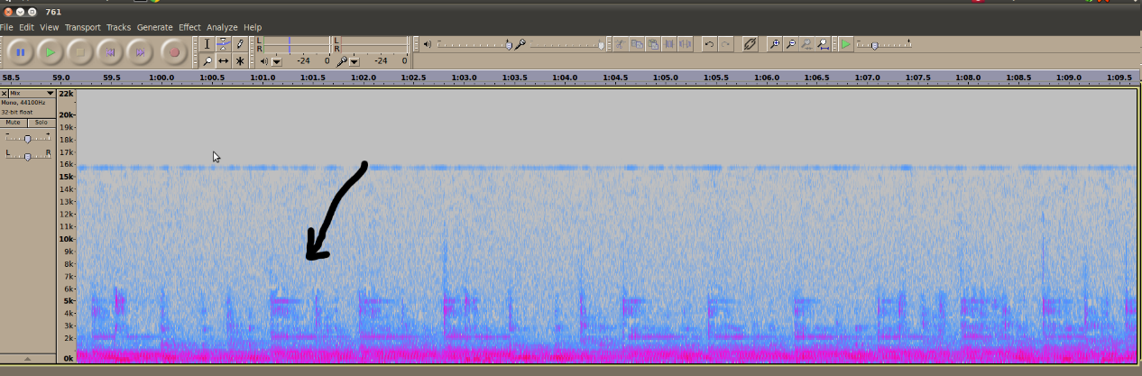  
<http://www.anony.ws/i/2013/01/09/x3Tr1.png>

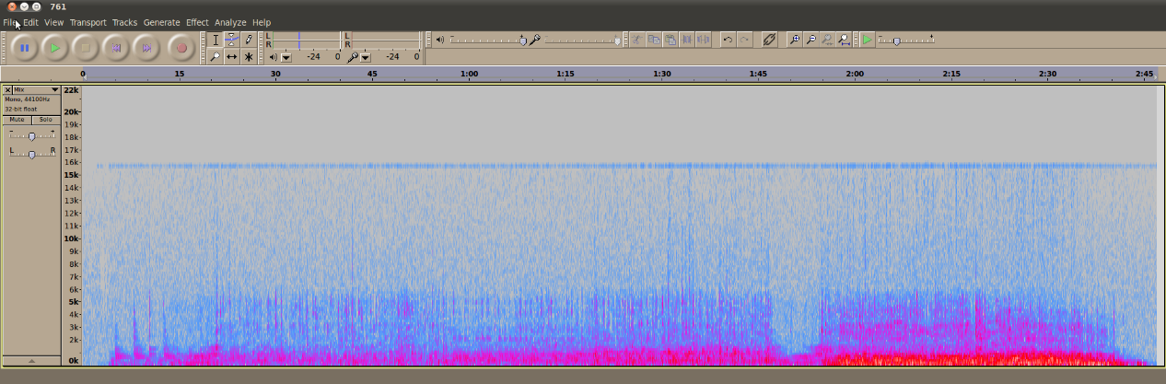  
<http://www.anony.ws/i/2013/01/09/XrucW.png>

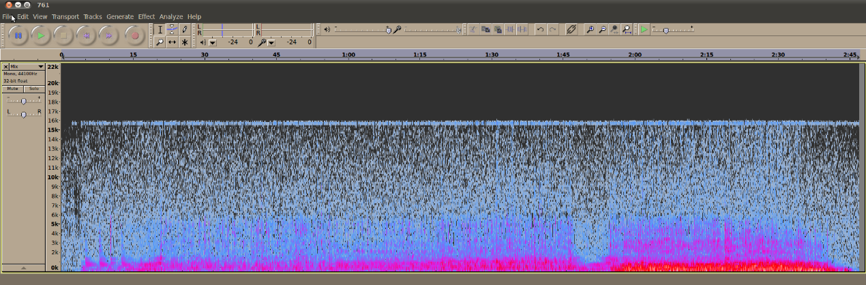  
<http://www.youtube.com/watch?v=ytVxSBM2OEQ>

ID tag:  
761.mp3  
Title: The Instar Emergence  
Artist: 3301  
Extra metadata: <http://prntscr.com/olycw>

The Instar Emergence 2:47

<https://pastee.org/ujpxy>   mp3 file  
<https://anonfiles.com/file/b4a0a572aa4e307facb9e75e37a364b5>

Observations:  
1595 277641 = 1031 x 1229 x 1259

If you count (add) each word from the poem  (using onion console tellnet or Gamatria Primus table) you get 1595 277641

No significant parable numbered 1595 277641 or 1031 or 1229 or 1259  was found in literature

[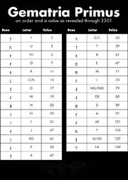](https://static.wikia.nocookie.net/uncovering-cicada/images/1/1a/Testout.jpg/revision/latest?cb=20130107123015)The length of the clip, 2:47 (2 minutes, 47 seconds), if converted to all seconds equals 167 seconds. 167 is prime and is the emirp of the mp3 file (761.mp3) and the Gematria value of, "The Instar Emergence".

## Meaning of Parable 1,595,277,641

Counting title "The Instar Emergence" [we get 761](http://pastebin.com/AfndPJa0) (emirp). Name of the file is 761.mp3

Result of xor-ing the twitter information with 761.mp3

Parable 1,595,277,641

Like the instar, tunneling to the surface\n

We must shed our own circumferences;\n

Find the divinity within and emerge.

Adding Gematria Primus values of letters in each line togather (without first line and wihtout \n) and then mutiplying summs of all three lines produces parable number.

Line 1 184+72+280+339+66+72+246 = 1259

Line 2 86+186+232+21+55+451 = 1031

Line 3 151+72+363+115+215+300 = 1229

1259*1031*1226 = 1,595,277,641

Count for "divinity"  is wrong. IT counts as 373 but according to V=U rule it should be 373.

**Observation: Gematria doesn't have a letter V in it. This is the only letter in the message without a value (the only other letter not defined in the Gematria is Q). If we take the latin convention that V = U  we get that 'divinity' = 376 => Line 3 = 1229.**

* [Python script](http://pastebin.com/vrfzRV08)
* (Not working anymore) [Soulseekah online gematria Primus http://codeseekah.com/cicada/count.html](http://codeseekah.com/cicada/count.html)
* For calculating gematria sums of words you can try Nessun0 bot on [IRC/Freenode channel #cicada](http://webchat.freenode.net/?channels=#cicada) by using command -count [word] (-help shows other available commands)

## Cosmo's analysis (studying music technology)

The  reversed music at the end is not in the same key as the rest of the song, the song was one guitar recorded by two microphones, the drums at the end are only one bass drum heavily edited.  
It has almost a drone bass note. What gets to me most about the song is this. It's a bad recording. As in it's been very badly recorded with what sounds like piss-poo equipment even for a bedroom set up. But it's very specifically edited.  
I've been exploring that idea as best I can. I'm going to try a couple more things out with it, see if i can't create an image out of it. But don't get bogged down on it, these guys are moving forwards, keep up with them, I highly doubt the mp3 is going to get any more useful than it's already been

<http://pastebin.com/CneUy8J4> these are all cosmos posts from 7th

<http://pastebin.com/XQ9rJSad>  full log if some posts look out of context

## Boney M (speculative claims)

Somebody suggested in chat that 761.mp3 song was inspired by Boney M - Ma Baker 1976 <http://www.youtube.com/watch?v=2E5sxuSRg6A> and even that is might have some connection to Freemasonry (no proof given so far)

## Other Information

I have isolated the 15Khz range and dropped it's pitch so we can here it. currently it sounds like cicadas when this is done

<https://anonfiles.com/file/c208d8fb6831b4cc858561da5e1aeceb>

<http://vocaroo.com/i/s1PnehBMGkmj>